

Noyes USB Instrument Driver Installation on Windows XP

Extract the files from the distribution file and place in a known directory.

- Plug in the Instrument.
- When the Found New Hardware Wizard box appears, click the Install from a list or specific (Advanced) radio button. Click Next.

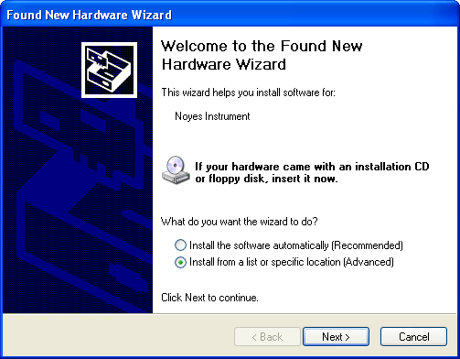

- The Please Choose Your Search and Installation Options dialog box will appear.

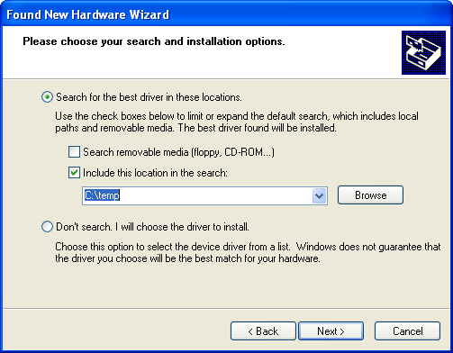

- Click the Search for the best driver in these locations radio button. Uncheck the Search removable media (floppy, CD-ROM…) box. In the “Include this location in the search:” field, type in the name of the directory the files were extracted to. Click Next.

- When the wizard completes its task, the following Hardware Installation box will appear. Click Continue Anyway.

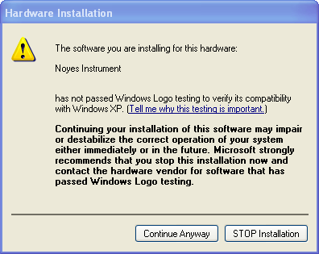

- The Completing the Found New Hardware Wizard box will appear. Click Finish.

